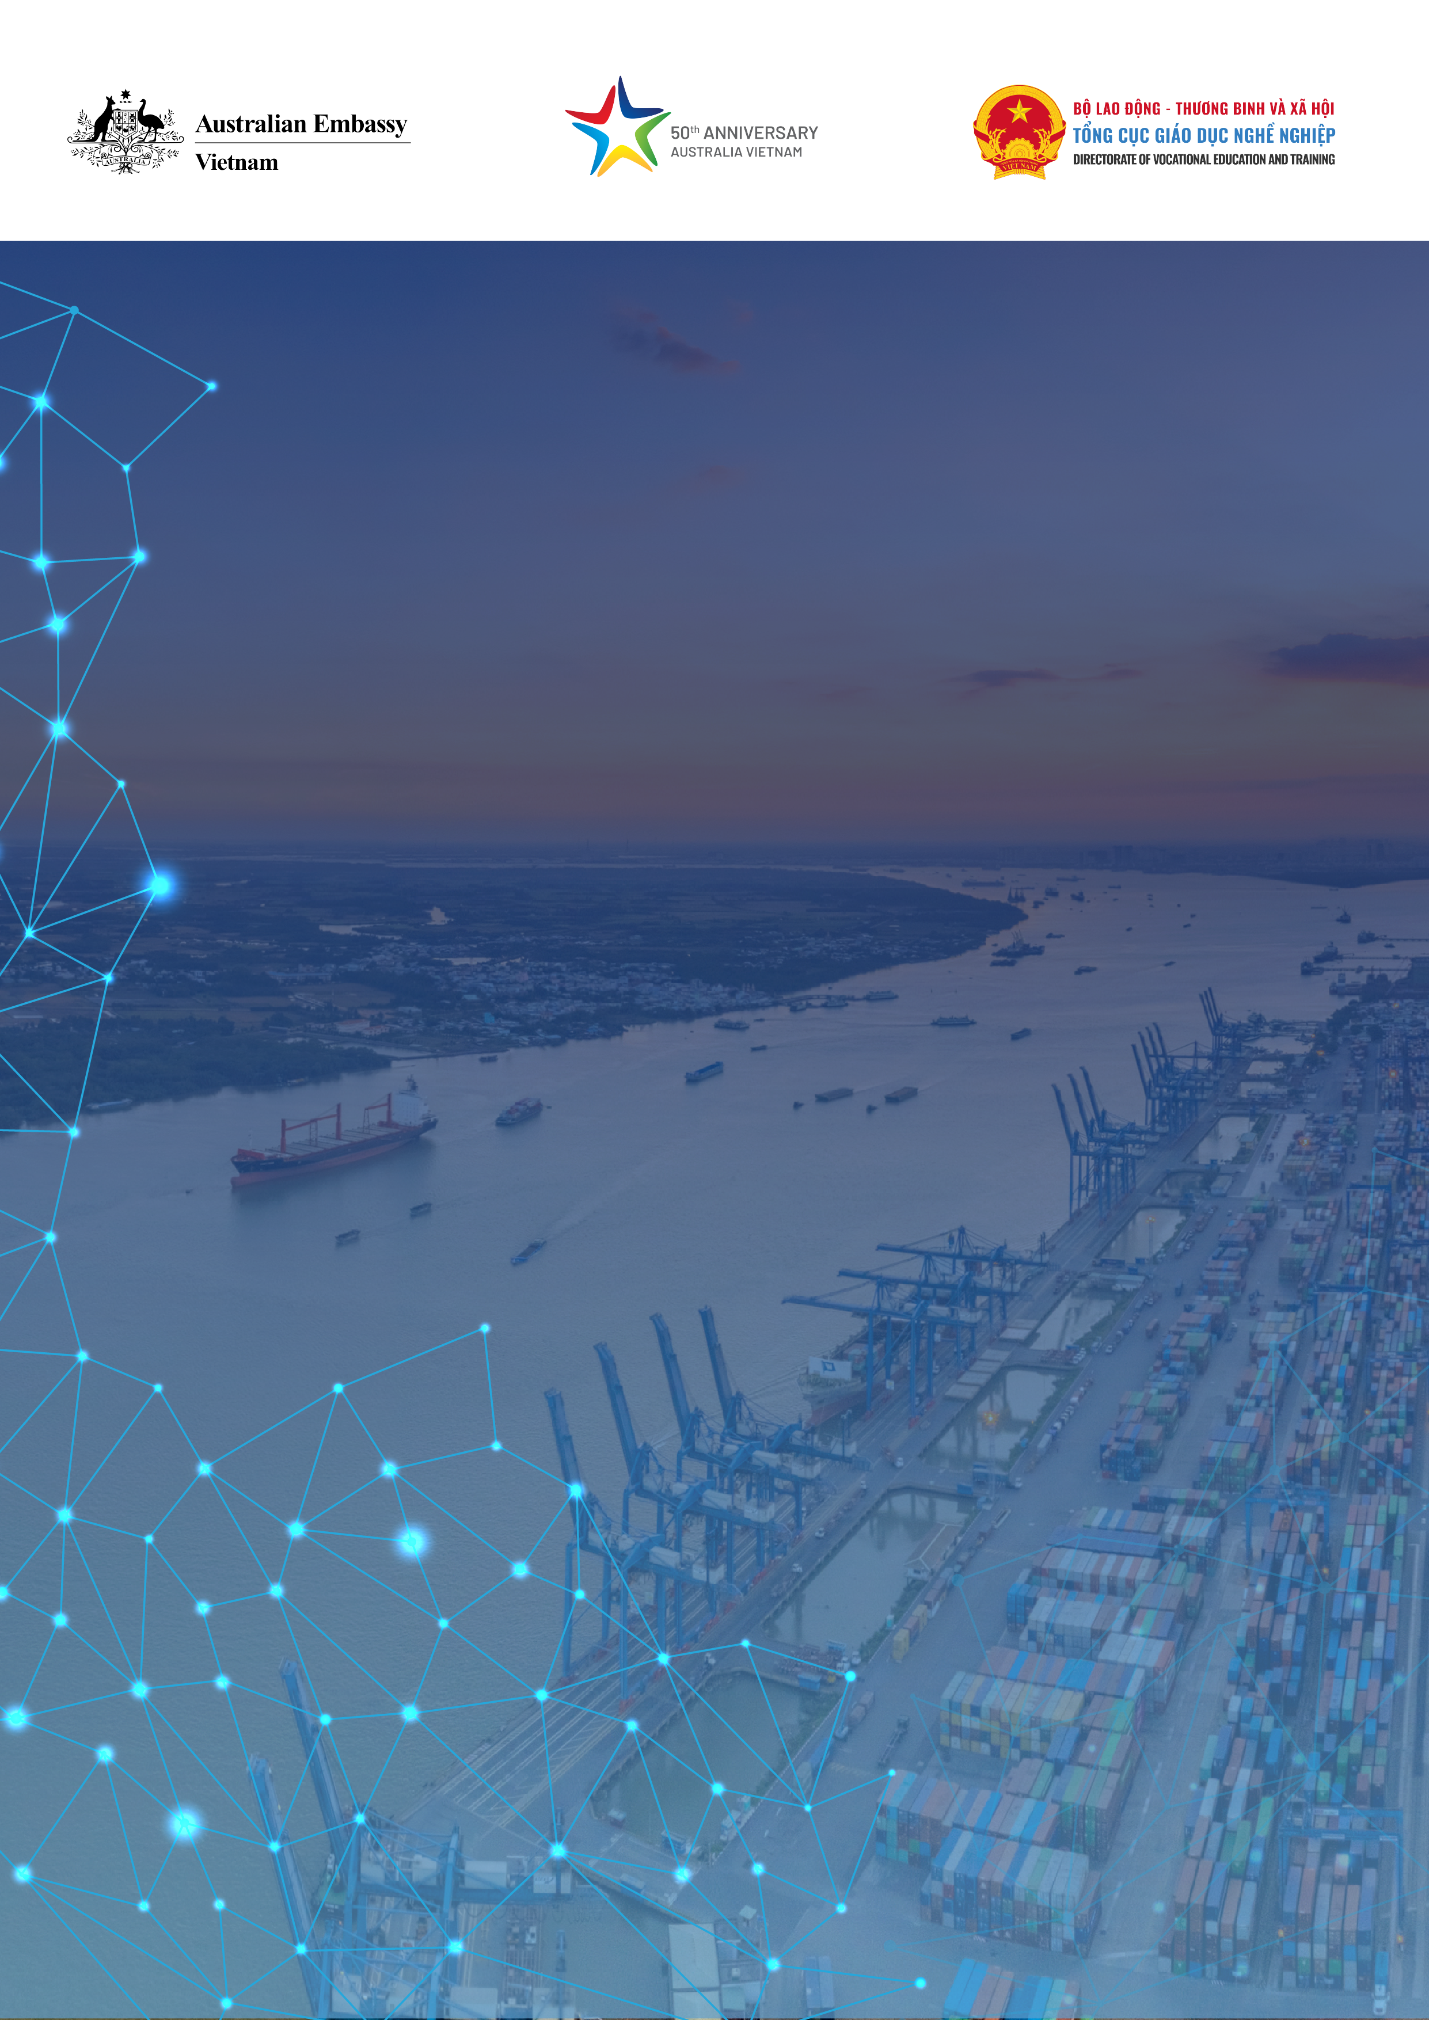

**DEVELOPING LOGISTICS TRAINING PROGRAMS IN THE CONTEXT OF DIGITAL TRANSFORMATION AT HO CHI MINH COLLEGE OF TRANSPORTATION**

Phan Huy Duc

Ho Chi Minh City College of Transportation

Hanoi, October 24, 2023

# 1. Background

According to Vietnam Logistics Business Association (VLA), the growth of Vietnam’s logistics sector has been about 14% - 16% in recent years. The industry size reaches about USD 40 - 42 billion per year. The quantity and quality of logistics services are improved, making an important contribution in bringing Vietnam's total import-export turnover in 2022 to USD 732.5 billion, an increase of 9.5% yoy. However, in the Logistics Performance Index (LPI) Report 2023 published by the World Bank (WB) in April 2023, Vietnam ranked 43rd, down 4 places compared to 39th in 2018[1]. Despite falling 4 places compared to 2018, the growth rate of Vietnam's logistics industry remains impressive amidst turbulences in the world economy.

According to a McKinsey study, digital transformation could previously take about 5 years to be applied to businesses and consumers. However, under the impact of the pandemic, this process has been shortened to just 8 weeks. Accordingly, the logistics industry is one of the leading industries in digital transformation. Digital transformation efficiency represents the competitive advantage of logistics businesses across all activities.

As for VET institutions offering logistics training programs, previous gaps between the training program’s learning outcomes and actual industry practices have always posed a big challenge. The challenge is even greater now that trainees, after completing the training program, are also required to have digital capabilities to perform tasks at logistics enterprises.

To meet practical requirements, in recent years, the Government, ministries and localities have issued many documents to direct, plan and elaborate digital transformation activities in VET. Specifically:

- Decision No. 2222/QD-TTg by the Prime Minister: Approving the digital transformation program in vocational education and training to 2025, with a vision to 2030;

- Decision No. 601/QD-LDTBXH dated July 5, 2022 by MOLISA on its plan to implement Decision No. 2222/QD-TTg;

- Decision No. 2550/QD-UBND dated June 22, 2023 by HCMC People's Committee issuing a plan to implement the digital transformation program in vocational education and training in HCM city to 2025, with a vision to 2030

For HCMC College of Transportation, this is an opportunity to improve the training quality of majors/concentrations in general and logistics in particular. However, digital transformation activities in VET at institutions also face significant challenges.

**2. Logistics training program development process**

The Scheme to develop logistics training programs has been implemented since 2012. However, at that time, the Ministry of Education and Training did not have a 4-digit code for this major at College level. Therefore, the project was suspended until the 4-digit Logistics major code was issued.

In 2017, the mandate of regulating VET activities was transferred to the Ministry of Labor, Invalids and Social Affairs (MOLISA). Also in this year, MOLISA issued Circular 04/2017/TT-BLDTBXH on the List of 4-digit major codes at diploma and higher diploma/college levels, including Logistics (higher diploma/college level - major code 5340141 and diploma level - major code 6340141). Following this, the Scheme to launch the logistics training program of the College of Transportation was officially resumed. In 2018, the College was officially licensed by the Directorate of Vocational Education and Training to enroll students in the Logistics major at higher diploma/college level.

To effectively deliver the logistics training program, the College determines and focuses on developing 3 fundamental elements:

(1). The training program is relevant and unique to the characteristics and competitive edges of the College;

(2). The trainers possess excellent professional capacity and pedagogical skills;

(3). Appropriate facilities and equipment for program delivery.

**2.1. Logistics training program development**

In the first version of the Logistics training program in 2017, the College referenced the FIATA Diploma training program to develop a framework curriculum and detailed syllabuses for subjects and modules. Realizing that the first version of the training program is relatively broad, in 2020, the College worked with Vietnam Logistics Research and Development Institute (VLI - a member of VLA), to revise it in better alignment with the College’s specific characteristics. Accordingly, in addition to basic modules, specialized modules and units focus on 4 pillars:

(1). Freight forwarding;

(2). Road transport;

(3). Warehousing;

(4). Inland waterway transport.

In 2022, the College continued to revise the program for the third time. Under this revision, with advice from businesses, the College added inclusive education content to the program delivery, applying competency-based training and assessment methods for specialized modules and restructure the duration of modules and units accordingly.

To deliver and develop the training programs, the College has made efforts to connect with logistics businesses since 2018. Specifically:

- Specialized research units: VLI, DRD;

- Supply chain solution providers: SmartLog (2020), AFR Solutions (2021), TKS (2023);

- Communication and support service providers: Vietnam Shipping Gazette;

- Logistics firms: Will Logistics, Hong Nam Single-member Limited Liability Company, AOA, VTA Logistics.

**2.2. Building capacity for trainers**

The College's Logistics training program is assigned to the Faculty of Economics which has 16 trainers across 4 subjects, namely Fundamental knowledge of the major, Accounting, Business Administration, and Transportation with professional qualifications, including:

- 6 trainers in Accounting;

- 2 trainers in Maritime Transportation;

- 2 trainers in Transportation;

- 6 trainers in Business Administration.

According to the above, apart from 2 trainers in Transportation, the College's Faculty of Economics does not have a trainer specializing in Logistics/Supply Chain. This is a huge challenge for the College. For the Faculty's trainers to master the training program, since 2018, the College has sent trainers to VLI to study under the FIATA Diploma program. To date, 13/16 trainers of the Faculty of Economics have completed their training, and the College’s trainers have completely mastered the training program, thereby developing curriculum and syllabuses that almost cover all subjects and modules.

In addition, the College also sends trainers to participate in short-term courses facilitated by Au4skills, such as CBTA courses, Introlog, skills training courses to support students with disabilities, female leaders, digital transformation and innovation, etc. These courses have helped the College's trainers raise awareness of inclusive education, build pedagogical and professional capacity. In particular, the College's trainers have applied competency-based training and assessment (CBTA) methods to the Logistics training program.

**2.3. Improve training facilities**

To serve the practicum components of Logistics course, the College has procured the following facilities for the Faculty of Economics:

- 2 practicum computer rooms;

- 1 simulated warehouse with full-fledged basic warehouse facilities;

- TKELog WMS warehouse management software;

- AFR Logistics software developed on the Salesforce platform, including 6 modules: Clo-CRM, Clo-TRS, Clo-FMS, Clo-WMS, Clo-TMS and Clo-CSM to practice the following contents:

+ Customer service;

+ Trading;

+ Freight forwarding;

+ Warehouse management;

+ Transportation;

+ Console products.

With the industry's strong digital transformation activities, investments in practicum facilities linked to the College's specialized modules, and adoption of CBTA methods, and digital transformation in Logistics training have been carried out in an methodical and planned manner despite numerous and challenges.

**3. Challenges in digital transformation in logistics training**

In the course of embracing digital transformation in Logistics training**,** the College has faced the following specific challenges:

(1). Limited digital infrastructure of institutions: With legacy digital infrastructure existing before adopting information technology to training and management, many items of the College's information technology infrastructure are now outdated and need to be improved;

(2). Resources to develop digital platforms and learning materials: Digital platforms and e-learning material repository represent an important factor to digital transformation in training activities. To develop an adequate digital platform and e-learning material repository, resources are needed, especially financial resources. A public VET institution like HCMC College of Transportation of features financial constraints.

(3). The digital competencies of the College trainers and staff remain limited and uneven: According to JISC, the digital capabilities framework encompasses six elements, namely ICT Proficiency, Information, Data and Media Literacies, Digital Creation, Problem Solving and Innovation, Digital Communication, Collaboration and Participation, Digital Learning and Development, and Digital Identity and Wellbeing. For the College's trainers, even the implication of digital competencies is already a new concept. However, online training amidst the Covid pandemic outbreak helped trainers improve their digital capabilities. In the coming time, the College will continue to promote activities to build digital capacity for their trainers and staff.

(4). Digital inequality: Digital inequality is present among learners. Most of students in rural, mountainous areas, and with financial hardship will have a slower start than other students when studying in a digital environment. For learners with disabilities, the problem of digital inequality is even further exacerbated. Therefore, it remains a challenge for the College to create an equal learning environment for all learners.

**Conclusion**

Although the College's Logistics training program at higher diploma level has only been offered since 2018, the training program has had strong and methodical developments. By identifying the main pillars in the training program, along with substantive and meaningful cooperation with businesses, the training program has promoted the College's advantages in the Logistics industry.

The goal of any training program is to help learners develop performance capacity to meet practical work requirements when working at an enterprise after graduation. The adoption of CBTA methods in Logistics courses by the College in recent years, although not covering all subjects and modules in the program, has contributed to improving the training quality for the College and is an important first step to replicate for all remaining subjects and modules in Logistics and other majors/concentrations.

Along with applying CBTA in training, digital transformation activities in training and management at the College will be two intertwined factors that help the College further improve and develop. To that end, in the coming time, the College will have to make efforts to develop and implement an action plan in the digital transformation scheme to tackle the challenges mentioned above.

1. # .Web portal of the Ministry of Finance: Vietnam Logistics Industry: Developing technology and increasing service value

  